AIM OF THE EXPERIMENT:
To determine the Optimum moisture content and maximum dry density of a soil by standard proctor compaction test.
APPARATUS REQUIRED:
- Special:
- Proctor mould (capacity 1000.0 cc, internal diameter 100mm, and effective height 127.3 mm.
- Rammer for light compaction (2.6Kg, with free drop of 310 mm).
- Mould accessories including detachable base plate, removable Collar.
- I.S. sieve 4.75 mm.
- General:
- Balance of capacity 10 kg, and sensitivity of 1 gm.
- Balance of capacity 200 gms and sensitivity of 0.01 gm.
- Drying oven.
- Desiccators.
- Containers for water content.
- Graduated Jar.
- Trimming knife.
- Large mixing tray.
THEORY:
Compaction is the process of densification of soil mass by reducing air voids. The purpose of laboratory compaction test is so determine the proper amount of water at which the weight of the soil grains in a unit volume of the compacted is maximum, the amount of water is thus called the Optimum Moisture Content (OMC). In the laboratory different values of moisture contents and the resulting dry densities, obtained after compaction are plotted both to arithmetic scale, the former as abscissa and the latter as ordinate. The points thus obtained are joined together as a curve. The maximum dry density and the corresponding OMC are read from the curve.
For example
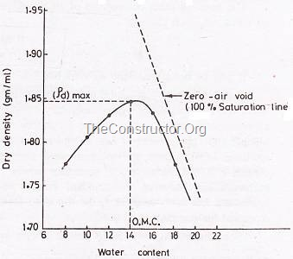
The standard equipment shown below,
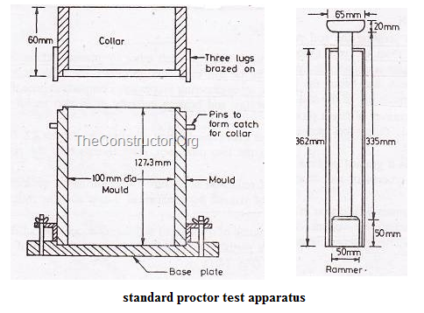
The wet density of the compacted soil is calculated as below,
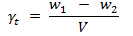
Where, w₁ = Weight of mould with moist compacted soil.
w₂ = Weight of empty mould.
V = Volume of mould.
The dry density of the soil shall be calculated as follows,
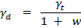
Where, t = wet density of the compacted soil.
w = moisture content

APPLICATION:
Compaction of soil increases the density, shear strength, bearing capacity, thus reducing the voids, settlement and permeability. The results of this are useful in the stability of field problems like earthen dams, embankments, roads and airfield. In such compacted in the field is controlled by the value of the OMC determined by laboratory compaction test. The compaction energy to be given by a compaction unit is also controlled by the maximum dry density determined in the laboratory. In other words, the laboratory compaction tests results are used to write the compaction specification for field compaction of the soil.
PROCEDURE:
- Take about 20 kg of soil and sieve it through 20 mm and 4.75 mm.
- A 100 mm diameter Proctor mould is to be used if the soil fraction that passes 4.75 mm sieve is greater than 80% by weight.
- Take about 2.25 kg of the soil sample and add water to get the moisture content round 8%. Leave the mix to mature for few minutes.
- Clean and grease gently the inside surface of the mould, and the base plate.
- Take the weight of empty mould with the base plate.
- Fir the collar and place the mould on a solid base.
- Place first batch of soil inside the mould and apply 25 blows of Standard rammer, so that the compacted layer thickness is about one-third height of the mould Scratch the top of the compacted soil before the second layer is placed Place the second batch of wet soil and follow the same procedure In all the soil is compacted in three layers, each given 25 blows of the standard rammer weighing 2.6 Kg and having a drop of 310 mm.
- Remove the collar, and trim of the excess soil with trimming knife. Clean the mould, and weight the mould with the compacted soil and the base plate.
- Take a representative sample from the mould and determine its water content.
- Repeat the above procedure for water content values of 13%, 17%, 20%, 22% and 25%.

PRECAUTIONS:
- Adequate period is allowed to mature the soil after it is mixed with water.
- The rammer blows should be uniformly distributed over the surface with spatula before next layer is placed.
- To avoid stratification each compacted layer should be scratched with spatula before next layer is placed.
- At the end of compaction test, the soil should not penetrate more than 5mm into the collar.

OBSERVATION AND CALCULATION TABLE:
- Diameter of mould, D (cm): __ _ _ _ _ _ _
- Height of mould, h (cm) : _ _ _ _ _ _ _ _
- Volume of mould, V (cc) : _ _ _ _ _ _ _ _

Weight of empty mould + Base plate
(w₁) ,kg
Weight of compacted soil + Base plate
(w₂) ,kg
Bulk unit weight of compacted soil
γ (gm/cc)
Water content
(w)
Dry unit weight
γ_{d} = γ / (1 + w), (gm/cc)

QUESTIONNAIRE:
- What is meant by dry side and wet side of optimum? Which side is preferred in the field compaction? Explain.
- Explain how the gravel content in the soil mass affect the laboratory compaction specifications.

- What is the energy imparted by the standard and modified compaction test?
- What are the approximate values of OMC and MDD for coarse grained and fine grained soils?

- What are the filed methods of compaction the soils?

- Due to compaction the parameters which increase in magnitude is
- Shear strength
- Void ratio
- % of air voids
- None
- Modified proctor test is used for
- Runways
- Highways
- Embankments
- Earthen dams
- Energy ratio in modified proctor test to standard proctor test is given by
- 4.55
- 4
- 3.55
- None
- For pure sandy soils
- Compaction curve is not useful
- A well defined OMC exists
- Modified proctor test is recommended
- Jodhpur miniature compaction test is recommended
- The 95% saturation line and 5% air voids line are
- Same
- Different
- Both a & b
- None
- Compaction of a soil is measured in terms of
- Dry density
- Specific gravity
- Compressibility
- Permeability
- Factors effecting the compaction are
- Water content
- Compaction energy
- Soil type
- All the above
- In a compaction test with increase in compactive effort
- Maximum dry density increase but OMC decreases
- The compaction cure is shifted to the left and higher
- Both the above
- Both maximum dry density and OMC increases
- Relative compaction is
- Similar to relative density
- A compaction process
- Dry density obtained in the field
- A ratio of ᵞd of field to the ᵞd of lab
- Standard proctor test is also known as
- I.S light compaction test
- I.S heavy compaction test
- none

PART – 2
ANIMATION STEPS
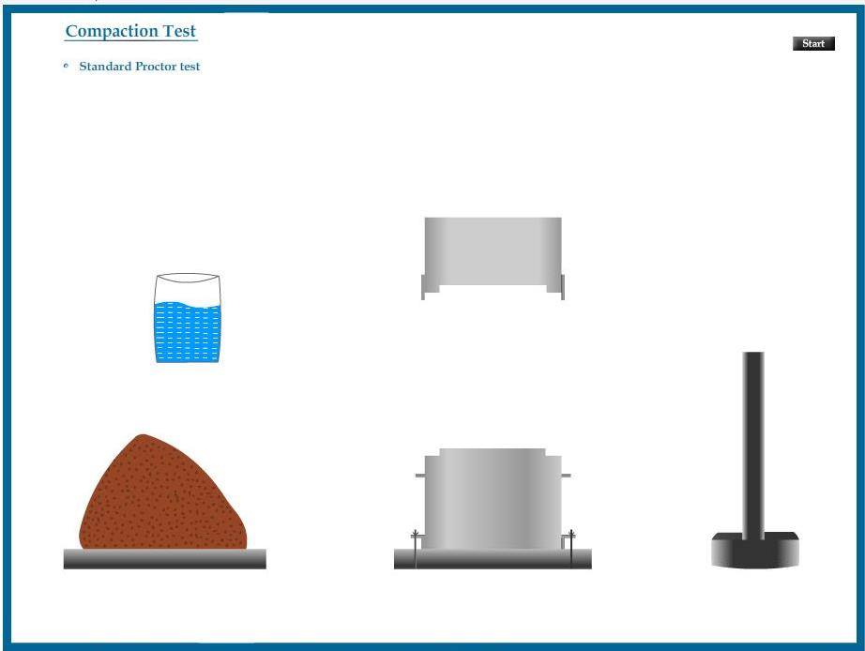

PART – 3
VIRTUAL LAB FRAME

